Problem Statement 4 - AI Powered Estimation Portal/Chatbot (Pick Any one of A, B, C or D)

- AI-Powered Collateral Valuation & Resale Liquidity Engine
Context: Why This Is a Real Problem
For NBFCs and secured lenders, property-backed lending hinges on two fundamental questions:
- What is the asset worth today?
- How easily can it be liquidated if required?
Most current valuation approaches rely on:
- Manual site inspections
- Broker inputs that are subjective and inconsistent
- Circle rates that often lag actual market conditions
This leads to:
- Large valuation variance
- Mispriced risk and conservative lending
- Slower credit decisioning and turnaround times

Core Problem Statement
Design a data-led valuation and liquidity engine that can consistently estimate both asset value and resale risk for property-backed lending.

Target Outputs
The system should produce:
- Estimated Market Value (₹ range)
- Distress Sale Value (₹ range)
- Resale Potential Index (0–100)
- Estimated Time to Liquidate (days range)
- Confidence Score (0–1)
- Key Risk Flags and Value Drivers

What You Are Actually Solving
This is not just a pricing model.
The objective is to build a market-aware collateral intelligence layer that combines:
- Intrinsic value (what the asset should sell for)
- Liquidity (how fast and how reliably it can be sold)
In practice, lenders care as much about exit certainty as valuation.

Feature Engineering Framework
- Location Intelligence (Primary Driver)




Core Inputs
- Detailed Location: Address / Lat-long
- Photo of exterior and interior (optional, but good to have)
Derived Signals
- Circle Rate Benchmark
Acts as the statutory floor value.
- Market Activity Proxies
Nearby listings, broker density, transaction indicators (where available).
- Infrastructure Proximity Index
Distance to metro/rail, highways, commercial hubs, schools, hospitals.
Strong driver of both price and resale velocity.
- Neighbourhood Quality Score
Residential vs mixed-use, planned vs unplanned zones.

- Property Characteristics


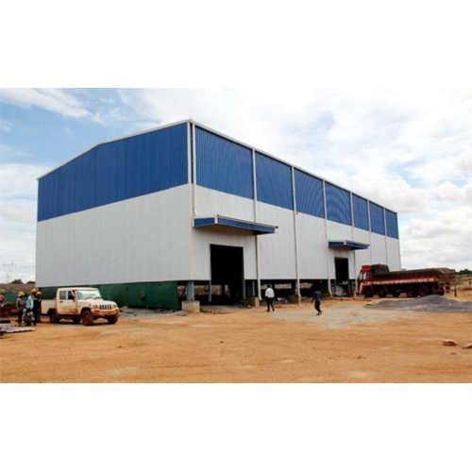

Core Inputs
- Property type: Residential / Commercial / Industrial
- Sub-type: Apartment, villa, plot, shop, warehouse
- Size: Carpet / built-up area, land parcel size
- Vintage:
  - New (<5 years)
  - Mid-age (5–15 years)
  - Old (>15 years)
- Floor level and accessibility (lifts, ground floor access)
These factors directly influence:
- Depreciation
- Buyer demand
- Usable life

3. Legal & Ownership Attributes
Inputs
- Freehold vs leasehold
- Clear title vs potential legal complexity (proxy indicators)
Impact
- Directly affects resale liquidity
- Drives conservative LTV limits in underwriting

4. Income & Usage Signals
Inputs
- Occupancy status: self-occupied / rented / vacant
- Rental yield proxy (if applicable)
Insight Properties with healthy rental yields tend to attract investors, improving resale certainty.

5. Market Dynamics Layer
Derived Features
- Supply–demand balance (listing density vs absorption indicators)
- Local price momentum (optional)
- Asset fungibility
  - Standard configurations (e.g., 2BHK apartments) → higher liquidity
  - Custom or niche assets → lower liquidity

Valuation and Liquidity Modeling
1. Market Value Estimation
Market Value is a function of:
- Circle rate benchmark
- Location premium
- Property type and size
- Age and depreciation
- Infrastructure score
- Rental yield (if applicable)
Output: Value range, not a point estimate.

2. Distress Sale Value
Distress Value = Market Value × Liquidity Discount
Liquidity discounts depend on:
- Asset type
- Location demand
- Legal clarity

3. Resale Potential Index (0–100)
A consolidated liquidity signal derived from:
Factor | Impact
Prime location | ↑
Standard configuration | ↑
High demand micro-market | ↑
Older construction | ↓
Legal complexity | ↓
Niche asset profile | ↓
Interpretation
- 80–100: Highly liquid
- 50–80: Moderate liquidity
- <50: Illiquid / specialised asset

4. Time-to-Liquidate Estimation
Time to Sell = f( Resale Index,
Property Type,
Market Activity Indicators )
Output should be expressed as a time range, not a single number.

Input Requirements
Mandatory
- Address or lat-long
- Property type and sub-type
- Size
- Age
Optional
- Rental details
- Legal status indicators
- Property images (bonus)

Sample Output Format
JSON
{
"market_value_range": [9500000, 11500000],
"distress_value_range": [7500000, 9000000],
"resale_potential_index": 72,
"estimated_time_to_sell_days": [45, 90],
"confidence_score": 0.68,
"key_drivers": [
"proximity_to_metro",
"standard_2bhk_configuration",
"mid_age_building"
],
"risk_flags": [
"high_micro_market_competition",
"moderate_building_age"
]
}

Fraud and Risk Considerations
Common issues to account for:
- Overstated property size
- Incorrect location tagging
- Property type misclassification
Expected safeguards:
- Size sanity checks against locality norms
- Location–property mismatch flags
- Configuration plausibility checks

Evaluation Criteria
Dimension | Weight
Valuation logic | 25%
Liquidity modeling | 25%
Feature depth | 20%
Practical deployability | 15%
Explainability | 15%

Constraints
- No proprietary transaction datasets assumed
- Allowed:
  - Circle rates
  - Public listings (optional)
  - Reasoned synthetic assumptions

What a Strong Solution Looks Like
Not:
“We trained a regression model to predict price.”
Instead:
“We designed a structured valuation and liquidity framework where location sets the base, property attributes adjust value, market forces define exit risk, and outputs are transparent and range-based.”

Why This Matters
This framework can directly evolve into:
- A core underwriting engine for LAP products
- A real-time valuation API for fintechs
- A credit-focused real estate intelligence layer for India

Final Framing
You are building a “Bloomberg Terminal for Real Estate Collateral”
where lenders see price, risk, and liquidity together, not in silos.

